**Project Title: Admin Dashboard for Academic and Administrative Management**

**TABLE OF CONTENTS**

1. **Introduction**

○ 1.1 Motivation

○ 1.2 Problem Statement

○ 1.3 Objectives of the Project

○ 1.4 Scope of the Project

○ 1.5 Project Introduction

○ 1.6 Overview of React JS

1. **SYSTEM ANALYSIS**

○ 2.1 Existing System

○ 2.2 Disadvantages of Existing System

○ 2.3 Proposed System

○ 2.4 Advantages of the Proposed System

1. **REQUIREMENT ANALYSIS**

○ 3.1 Functional Requirements

○ 3.2 Non-Functional Requirements

○ 3.3 Hardware Requirements

○ 3.4 Software Requirements

○ 3.5 System Architecture

1. **SYSTEM DESIGN** 
   1. 4.1 Input Design
2. **IMPLEMENTATION AND RESULTS** 
   1. 5.1 Module Implementation Details

5.1.1 Attendance Module

5.1.2 Curriculum Module

5.1.3 Dashboard Module

5.1.4 Fee Details Module

5.1.5 Student Module

5.1.6 Timetable Module

○ 5.3 Output Screens (with Screenshots)

1. **SYSTEM TESTING** 
   1. 6.1 Feasibility Study

6.1.1 Economic Feasibility

6.1.2 Technical Feasibility

6.1.3 Social Feasibility

○ 6.2 Types of Testing

6.2.1 Unit Testing

6.2.2 Integration Testing

6.2.3 Functional Testing

6.2.4 Usability Testing

6.2.5 Performance Testing

6.2.6 Security Testing

○ 6.3 Test Cases (for each module)

1. **CONCLUSION**
2. **FUTURE ENHANCEMENTS**
3. **REFERENCES**

# ABSTRACT

This project introduces an Admin Dashboard, a centralized digital platform designed to streamline and modernize academic and administrative processes within educational institutions. The system addresses the challenges of traditional manual methods, which are often time-consuming and difficult to maintain, by leveraging efficient digital tools.

The Admin Dashboard provides administrators with essential tools to efficiently manage student records, schedules, and financial details. Key modules include Student Data Management, Timetable Management, Fee Management, Curriculum Management, and Attendance Management.

Notably, this system enhances efficiency by automating tasks, improving data accuracy, and facilitating communication between administrators and other stakeholders. The use of React JS provides a user-friendly web interface for easy access and management of administrative functions.

This comprehensive tool aims to improve overall academic administration, enhance institutional management, and contribute to a more informed and engaged educational environment.

# 

# 

# 1. INTRODUCTION

## 1.1 MOTIVATION

The motivation behind this project lies in revolutionizing attendance management within educational institutions. Traditional methods of attendance tracking are not only time-consuming but also present significant challenges in maintaining accurate records. This creates a pressing need for a more efficient and reliable solution. By employing cutting-edge Deep Learning technology for face recognition, the system ensures accuracy and efficiency in tracking attendance. This automated approach not only streamlines administrative tasks for educators but also promotes a culture of punctuality and accountability among students. Furthermore, the integration of real-time notifications through platforms like Fast to SMS fosters seamless communication between schools and parents, fostering greater involvement in their child's education. This capability for instant communication enhances transparency and allows parents to stay informed about their child's attendance, marks, and behavior. Ultimately, this initiative seeks to enhance student monitoring, improve parental engagement, and contribute to the overall efficiency and effectiveness of the educational process, creating a more informed and engaged educational environment for all stakeholders.

## 1.2 PROBLEM STATEMENT

Traditional manual attendance management in educational institutions is time-consuming, error-prone, and challenging to maintain, adversely affecting class efficiency and data accuracy.

This reliance on manual processes introduces several critical problems. Firstly, the manual recording of attendance is labor-intensive for educators, requiring them to spend valuable class time on administrative tasks rather than instruction. This not only reduces overall teaching effectiveness but also disrupts the flow of the learning environment. Secondly, manual attendance records are susceptible to errors, including miscalculations, omissions, and запись errors, which compromise the accuracy and reliability of attendance data. These inaccuracies can have cascading effects, impacting student performance evaluations, resource allocation, and institutional reporting.

Furthermore, traditional attendance systems often lack real-time tracking capabilities, hindering the ability of educators to monitor student attendance patterns and address attendance-related issues promptly. The absence of timely data also limits parental involvement, as parents may not receive immediate notifications about their children's attendance. This project addresses these issues by developing a Time-Based Attendance Management System that utilizes Deep Learning-based Face Recognition to automate attendance tracking accurately. The main challenge lies in creating a reliable facial recognition system capable of efficiently identifying and recording student attendance, which will be securely stored in a database. Additionally, the system will send automated messages to parents via the Fast to SMS website, enhancing communication between schools and parents to improve student management and engagement.

**1.3 Objectives of the Project**

Create a secure database infrastructure for storing attendance data, including timestamps and relevant student information. This objective focuses on establishing a robust and secure system for data storage, ensuring the confidentiality, integrity, and availability of attendance records and associated student data.

Implement a user-friendly web-based interface using the Flask framework for easy access and management of attendance records. This involves the development of an intuitive and accessible interface that allows administrators and educators to efficiently manage, view, and analyze attendance data.

Integrate a messaging feature through the Fast to SMS website to automatically notify parents about their children's attendance, marks, and behavior. This objective aims to enhance communication between educational institutions and parents by providing timely updates and notifications regarding student attendance and performance.

Enhance efficiency, reduce errors, and improve communication between educational institutions and parents, fostering a more informed and engaged educational environment. Ultimately, this project seeks to provide a comprehensive solution that streamlines attendance management, improves data accuracy, reduces administrative burden, and promotes greater collaboration between schools and families.

### 1.4 Scope of the Project

The scope of this project encompasses the design and implementation of a Time-Based Attendance Management System tailored for educational institutions. It involves the development of a system that uses face recognition technology for automated and accurate attendance tracking. This includes the integration of existing face recognition systems or libraries to detect and identify students' faces from images or video streams, focusing on how these technologies are incorporated into the attendance system's workflow. The system's capabilities will include capturing images or video, processing this input to identify faces, and matching those faces against a database of enrolled students.

The system will store attendance data securely in a database for future analysis and reporting. This database will be designed to efficiently manage and retrieve attendance records, along with associated student information, emphasizing the database structure, data types, and relationships between data elements. Functionalities will be included to record attendance timestamps, student identification details, and other relevant information. The reporting features will enable administrators to generate attendance reports based on various criteria, such as date, class, or student.

Additionally, the system will integrate a feature to send automated notifications to parents through, providing real-time updates on attendance, marks, and behavior. This integration will involve utilizing web services or APIs to communicate with the SMS platform and automate the sending of messages to parents, detailing the specific data transmitted and the communication protocols used. The scope includes defining the events that trigger notifications, the content of those notifications, and the delivery mechanisms.

This project aims to streamline attendance management, enhance communication between educational institutions and parents, and contribute to efficient student monitoring and parental involvement in education. The project's scope is focused on providing a technological solution to improve attendance processes and communication within the educational ecosystem by applying face recognition technology, with a clear emphasis on the system's architecture, functionality, and interactions with external systems

### 1.5 Project Introduction

In modern educational institutions, efficient and effective administration is crucial for smooth operations and academic success. The Admin Dashboard project is an initiative to develop a centralized digital platform that streamlines academic and administrative processes, providing administrators with the tools they need to manage student records, schedules, financial details, and curriculum effectively.

This dashboard is designed to replace or enhance traditional, often manual, administrative tasks with a digital solution that improves efficiency, reduces errors, and enhances communication. Traditional administrative processes often involve fragmented systems or paper-based methods, leading to data silos, redundancy, and difficulties in accessing information quickly. The Admin Dashboard addresses these challenges by consolidating key functions into a single platform, aiming to simplify administrative workflows and provide administrators with a comprehensive overview of critical institutional data.

The project focuses on creating a system that provides a unified interface for various administrative tasks. This approach aims to reduce the time and effort required for routine administrative functions, allowing administrators to focus on more strategic initiatives.

Furthermore, the dashboard is intended to improve the accuracy and reliability of administrative data by minimizing manual data entry errors and providing tools for data validation and consistency checks.

By integrating key functions into a single platform, the Admin Dashboard aims to simplify administrative workflows and provide administrators with a comprehensive overview of critical institutional data. This will lead to better decision-making, improved resource allocation, and ultimately, a more effective and efficient educational environment

### 1.6 Overview of React JS

This Admin Dashboard is built using React JS, a powerful and flexible JavaScript library for building dynamic and interactive user interfaces. React JS was chosen as the front-end technology for this project due to its suitability for developing complex, single-page applications (SPAs) like the Admin Dashboard. Its component-based architecture, efficient rendering, and rich ecosystem make it an ideal choice for creating a robust and maintainable application.

Key features and benefits of React JS that are particularly relevant to this project include:

**Component-Based Architecture**: React promotes the development of UIs by breaking them down into smaller, reusable, and independent components. Each component encapsulates its own logic and rendering, making it easier to manage, test, and update different parts of the application. This modular approach is crucial for a complex dashboard like this, where different modules (e.g., student management, timetable) can be developed and maintained independently.

**Virtual DOM**: React uses a virtual DOM (Document Object Model), which is an in-memory representation of the actual DOM. When changes occur in the application's 1 state, React efficiently updates 2 the virtual DOM and then calculates the minimal set of changes needed to update the actual DOM in the user's browser. This optimization significantly improves performance, especially when dealing with frequent data updates, which is common in an admin dashboard.

**JSX**: JSX (JavaScript XML) is a syntax extension that allows developers to write HTML-like code within JavaScript. It provides a more declarative and intuitive way to describe the structure of UI components, making the code more readable and easier to understand. This improves the developer experience and facilitates the creation of complex UI layouts.

**Declarative Programming**: React encourages a declarative programming style, where developers describe *what* the UI should look like based on the data, rather than specifying *how* to manipulate the DOM to achieve that look. This simplifies development and makes the code more predictable and maintainable.

**Rich Ecosystem and Community**: React has a large and active community, which provides a wealth of resources, libraries, and tools. This extensive ecosystem offers solutions for various aspects of web development, such as state management (e.g., Redux, Context API), routing (e.g., React Router), aform handling. This availability of resources and community support accelerates development and ensures access to best practices.

In the context of this Admin Dashboard, React JS enables the creation of a user-friendly, interactive, and efficient interface that allows administrators to easily navigate, manage data, and perform their tasks effectively. Its component-based structure allows for the modular development of different dashboard sections, its virtual DOM ensures smooth performance, and its rich ecosystem provides the necessary tools for building a comprehensive and robust application.

**2. SYSTEM ANALYSIS**

● **2.1 Existing System**

Many institutions rely on a combination of manual and fragmented digital systems for their administrative tasks, leading to inefficiencies and errors. This often involves:

**Separate Systems for Different Functions:** Institutions may use distinct software

or manual processes for managing student records, timetables, fees, curriculum, and attendance. This lack of integration leads to data silos, redundancy, and difficulties in accessing a holistic view of information. For example, student information might be stored in one system, while fee details are maintained in another, requiring manual reconciliation and increasing the risk of errors.

**Manual Data Entry and Paper-based Processes:** Even when some digital tools are used, significant manual data entry and paper-based processes may still be involved. This is time-consuming, labor-intensive, and prone to human error. Examples include manually entering student grades, printing out timetables, or processing fee payments using paper receipts.

**Outdated or Inefficient Software:** Some institutions may use older software systems that are not user-friendly, lack modern features, or are not optimized for current workflows. These systems might be slow, difficult to navigate, and lack the ability to generate insightful reports or analytics.

**Lack of Centralized Communication Tools:** Communication between administrators, faculty, students, and parents may rely on disparate channels, such as email, phone calls, or physical notices. This can lead to delays, miscommunication, and a lack of transparency. These fragmented and often outdated systems result in.

**Increased Administrative Burden:** Staff spend excessive time on routine tasks, reducing their productivity and ability to focus on strategic initiatives.

**Data Inconsistencies and Errors:** Lack of integration and manual data entry lead to discrepancies, inaccuracies, and difficulties in maintaining data integrity.

**Inefficient Workflows:** Processes are often cumbersome, time-consuming, and lack automation, slowing down administrative operations.

**Poor Communication and Transparency:** Lack of centralized communication tools hinders effective communication and reduces transparency among stakeholders.

**Limited Access to Information:** It is difficult to access a comprehensive and real-time view of institutional data, hindering informed decision-making. This revised description provides a more accurate representation of the challenges faced by institutions using fragmented administrative systems, setting the stage for the need for a centralized Admin Dashboard.

**2.2 Disadvantages of Existing System**

Many educational institutions, despite advancements in technology, still grapple with outdated or fragmented administrative systems that lead to a range of disadvantages.

These inefficiencies not only hinder the smooth operation of the institution but also impact the quality of education and the experience of students and staff. Some of the key disadvantages include

**Time-Consuming Manual Processes:** A significant portion of administrative tasks is often performed manually, requiring staff to spend excessive time on routine and repetitive activities. This includes tasks such as:

Manually entering student data into spreadsheets or databases. Generating reports by compiling data from various sources.Processing fee payments using paper-based receipts. Creating and distributing timetables manually. Tracking student attendance using paper registers.

These manual processes not only consume valuable time but also reduce the productivity of administrative staff, preventing them from focusing on more strategic and important responsibilities.

**Data Inaccuracy and Redundancy:** The use of disparate systems and manual data entry often leads to inconsistencies and errors in data. This can result in:

Conflicting information across different systems.Errors in student records, fee calculations, or timetable schedules. Duplicate data entry, leading to wasted effort and increased storage requirements. Difficulty in maintaining data integrity and accuracy. These inaccuracies can have serious consequences, such as incorrect billing, scheduling conflicts, or inaccurate reporting.

**Limited Transparency and Tracking:** Existing systems often lack the ability to provide real-time visibility into key administrative processes and data. This results in:

Difficulty in tracking student progress, fee payments, or attendance patterns. Lack of transparency in administrative decisions and processes. Inability to generate timely and accurate reports Hindered communication and collaboration among staff, students, and parents. This lack of transparency and tracking capabilities can lead to poor decision-making and reduced accountability

**Inefficient Communication:** Communication between different departments, staff, students, and parents is often fragmented and relies on outdated methods, such as:

Email chains that are difficult to follow. Phone calls that are time-consuming and lack documentation. Physical notices that are easily missed. This inefficient communication can lead to delays, miscommunication, and a lack of coordination.

**Lack of Integration:** Disparate systems that do not integrate with each other create data silos and hinder the flow of information. This results in:

Difficulty in accessing a holistic view of institutional data. Increased effort required to reconcile data from different systems. Inability to automate workflows across different departments. This lack of integration can significantly reduce efficiency and increase complexity.

**Scalability Issues:** Outdated systems may not be able to handle the growing needs of the institution, leading to:

Slow performance and long response times. Inability to accommodate increasing data volumes and user loads. Difficulty in expanding the system to support new features or modules. This lack of scalability can hinder the institution's growth and development.

* 1. **proposed system**

The proposed system aims to revolutionize attendance management in educational institutions by implementing Deep Learning-based Face Recognition for automated attendance tracking. This modernized approach eliminates the drawbacks of the manual system, offering efficiency and accuracy. Additionally, as an enhancement, the system will integrate with the Fast to SMS website, enabling automatic notifications to parents regarding their children's attendance, academic marks, and behavior. This feature fosters better communication between the institution and parents, enhancing parental involvement and ensuring that they stay informed about their child's educational progress. Overall, the proposed system combines cutting-edge technology with improved communication for a more efficient and engaged educational environment.

* 1. **advantages of proposed system**

Advantages of the Proposed Time-Based Attendance Management System:

* + 1. Enhanced Accuracy: The Deep Learning-based Face Recognition system ensures precise attendance tracking, reducing the chances of errors in recording attendance data.
    2. Real-time Monitoring: The system allows for real-time attendance updates, enabling educators to promptly address attendance-related issues and maintain class efficiency.
    3. Improved Parental Engagement: Integration with the Fast to SMS website provides parents with timely notifications about attendance, marks, and behavior, fostering active parental involvement in their child's education.
    4. Time Efficiency: Automation reduces the time spent on manual attendance-taking, allowing educators to allocate more time to instructional activities.
    5. Data Security: The secure database infrastructure safeguards attendance records, ensuring the confidentiality and integrity of sensitive student data .

### 3. REQUIREMENT ANALYSIS

**3.1 Functional Requirements**

**Student Management**: CRUD operations on student records.

**Timetable Scheduling**: Create, edit, and assign classes.

**Fee Management**: Track payments and pending dues.

**Curriculum Management**: Update and access course details.

**Attendance Management**: Record, update, and generate reports.

**3.2 Non-Functional Requirements**

Non-functional requirements define the quality attributes and constraints that the system must adhere to. These requirements are critical for ensuring the system's usability, performance, reliability, and security.

**Performance:** The system should provide fast and optimized data retrieval and processing to ensure a responsive user experience.

The system should be able to handle a large number of concurrent users without significant performance degradation. Data retrieval and display should be optimized to minimize loading times. The system should be scalable to accommodate future growth in data volume and user load.

**Security:** The system must implement robust security measures to protect sensitive data and prevent unauthorized access.

User authentication mechanisms should be secure and reliable, using strong passwords or multi-factor authentication Data encryption should be used to protect sensitive data during storage and transmission. Access control mechanisms should be implemented to restrict access to specific modules or data based on user roles and permissions. The system should be protected against common security threats, such as

SQL injection, cross-site scripting (XSS), and data breaches.

**Usability:** The system should have an intuitive and user-friendly user interface

(UI) to ensure efficient and effective use by administrators.

The UI should be consistent, clear, and easy to navigate. The system should provide helpful error messages and user guidance. The design should adhere to accessibility guidelines to ensure usability for users with disabilities.

**Reliability:** The system should be reliable and stable, with minimal downtime and data loss.

The system should be thoroughly tested to ensure its stability and functionality. Data backups and recovery mechanisms should be implemented to prevent data loss. The system should be designed to handle errors gracefully and provide informative error messages.

**Maintainability:** The system should be designed to be easily maintainable and upgradable.

The codebase should be well-structured, modular, and easy to understand. The system should be designed to accommodate future changes and enhancements. Proper documentation should be provided to facilitate maintenance and support.

**3.3 Hardware Requirements**

**Server:**

A high-performance server with a multi-core processor (e.g., Intel Xeon or equivalent).Sufficient RAM to handle concurrent user load and data processing (e.g., 16GB or more). Scalable storage to accommodate the database and application files (e.g., SSD or RAID configuration). A stable and reliable operating system (e.g., Linux or Windows Server). A dedicated network connection with sufficient bandwidth.

**3.4 Software Requirements**

The software requirements for the Admin Dashboard system include the technologies and tools used for development, deployment, and operation.

**Front-end:**

**React JS:** A JavaScript library for building user interfaces.

**HTML:** For structuring the web pages.

**CSS:** For styling the web pages.

**JavaScript:** A scripting language for adding interactivity to the web pages.

**Back-end:**

**Node.js:** A JavaScript runtime environment for building server-side applications.

**Express.js:** A Node.js web application framework.

**Operating System:** Windows 7/8/10

**IDE/Workbench:** PyCharm Technology: Python 3.6+

**Server Deployment:** Xampp Server

**Database:** MySQL

**Libraries:** Flask, Pandas, mysql.connector, os, numpy

**3.5 System Architecture**

The system architecture provides a high-level overview of the system's components and their interactions. A typical architecture for a web-based Admin Dashboard can be described as follows:

**Front-end:** The front-end consists of the user interface that administrators interact with. It is built using React JS, HTML, CSS, and JavaScript. The front-end handles user input, displays data, and communicates with the back-end through API requests.

**Back-end:** The back-end is responsible for handling server-side logic, processing data, and interacting with the database. It is built using Node.js and Express.js. The back-end exposes APIs (Application Programming Interfaces) that the front-end can use to retrieve and manipulate data.

**Database:** The database stores the application's data, including student records, timetable information, fee details, curriculum data, and attendance records.

MongoDB is used as the database in this case.

**Communication:** The front-end and back-end communicate with each other using standard web protocols, such as HTTP or HTTPS. API requests are used to exchange data between the client and the server.

1. **System Design**

**4.1 Input Design for the Admin Dashboard**

In the context of the Admin Dashboard, input refers to the data that administrators and other users will enter into the system to manage academic and administrative operations. Effective input design is crucial to ensure data accuracy, efficiency, and user satisfaction. The design of input methods and interfaces must consider the various modules of the dashboard, including student management, timetable scheduling, fee management, curriculum management, and attendance management.

Well-designed input forms and screens within the Admin Dashboard should have the following properties:

**Relevance:** Each input field and form should be directly relevant to the specific data being collected or managed (e.g., student details, course information, fee payments).

**Accuracy:** Input mechanisms should minimize the possibility of errors through data validation, input masks, and clear labeling.

**Completeness:** Input designs should ensure that all necessary data is captured, with clear indicators for required fields.

**Efficiency:** Input processes should be streamlined to reduce the time and effort required from users, utilizing features like auto-fill, drop-down menus, and logical field grouping.

**Clarity:** Input fields and forms should be clearly labeled and provide context or instructions when needed.

**Consistency:** Input methods and styles should be consistent throughout the dashboard to provide a unified user experience.

To achieve these properties, the input design for the Admin Dashboard will consider the following:

**Data Entry Forms:**

Designing user-friendly forms for entering and updating data, such as student information, course details, and fee payments. Implementing appropriate input fields (e.g., text fields, date pickers, drop-down menus) for different data types. Using clear labels and instructions to guide users through the data entry process.

**Data Validation:**

Implementing validation rules to ensure data accuracy and integrity (e.g., checking for correct data types, required fields, and valid ranges). Providing informative error messages to guide users in correcting invalid input.

**User Interface Components:**

Utilizing UI components (e.g., buttons, checkboxes, radio buttons) to facilitate user interaction and input. Designing intuitive navigation and workflows for data input and management.

**Automated Input:**

Exploring the potential for automated data input where appropriate (e.g., importing data from external systems).

**Attendance Input:**

Designing input methods for recording student attendance, which may include manual entry or integration with automated attendance systems.

**5.IMPLEMENTATION AND RESULTS**

This section describes the implementation details of each module within the Admin Dashboard, explaining the functionality and key aspects of their development.

● **5.1 Module Implementation Details**

**5.1.1 Attendance Module**

The Attendance Module is responsible for managing student attendance records.

**Functionality:**

Recording student attendance for individual classes or sessions. Providing different options for attendance input (e.g., manual entry, integration with external systems).Updating and modifying attendance records as needed.Generating various attendance reports, including student-specific reports, class summaries, and overall attendance statistics.Managing attendance policies and rules.

**Implementation Details:**

This module would involve creating a user interface for recording attendance, which might include features like class selection, student lists, and attendance status options. A database would be used to store attendance records, with fields for student ID, class ID, date, time, and attendance status. Logic would be implemented to generate different types of attendance reports based on user-defined criteria.

**5.1.2 Curriculum Module**

The Curriculum Module provides tools for managing and accessing academic curriculum details.

**Functionality:**

Adding new courses or subjects to the curriculum. Updating and modifying existing course details, such as syllabus, learning outcomes, and materials. Managing academic calendars and schedules.Providing access to course details and syllabi for administrators.Managing program structures and regulations.

**Implementation Details:**

This module would involve creating interfaces for defining and editing course information, including fields for course name, description, credits, and syllabus. A database would be used to store curriculum data, with relationships between courses, programs, and departments. Functionality would be implemented to manage academic calendars, schedules, and program structures.

○ **5.1.3 Dashboard Module**

The Dashboard Module provides a centralized overview of key administrative data and system activities.

**Functionality:**Displaying key performance indicators (KPIs) related to student enrollment, fees, attendance, and other relevant metrics. Providing a summary of recent activities and events within the system. Displaying upcoming events and deadlines.Providing visual representations of data through charts and graphs.

**Implementation Details:** This module would involve creating a user interface that displays relevant data and visualizations. Data would be retrieved from other modules and aggregated to provide a comprehensive overview. Libraries or tools would be used to generate charts and graphs.

○ **5.1.4 Fee Details Module**

The Fee Details Module provides functionalities for managing student fee records and financial transactions.

**Functionality:**

Tracking student fee payments and generating reminders for pending dues.Managing fee structures for different programs or classes.Generating fee receipts and financial reports.Updating fee payment status and managing fee discounts or waivers.

■ **Implementation Details:**

This module would involve creating interfaces for recording fee payments, generating invoices, and managing fee structures. A database would be used to store fee-related data, with fields for student ID, fee amount, payment date, and payment status Logic would be implemented to calculate fee dues, generate reports, and manage financial transactions

.

.

○ **5.1.5 Student Module**

The Student Module provides functionalities for managing student records and related information.

**Functionality:**

Adding new student records, including personal and enrollment details. Updating and modifying student information.Searching for students based on various criteria. Generating student lists and reports.

**Implementation Details:**

This module would involve creating interfaces for entering and updating student data, including fields for student ID, name, contact information, and enrollment details. A database would be used to store student records, with appropriate relationships to other modules. Functionality would be implemented to search, filter, and generate reports on student data.

○ **5.1.6 Timetable Module**

The Timetable Module provides tools for scheduling classes, modifying timetables, and managing class assignments.

**Functionality:**

Creating new timetables for different programs or classes.Editing and modifying existing timetables.Assigning teachers to specific classes or subjects. Viewing and generating timetable schedules.

**Implementation Details:**

This module would involve creating interfaces for defining and editing timetables, including fields for class schedules, teacher assignments, and classroom allocation. A database would be used to store timetable data, with relationships between classes, teachers, and classrooms. Logic would be implemented to manage scheduling conflicts and generate timetable reports.

**5.2 Output Code (Images)**

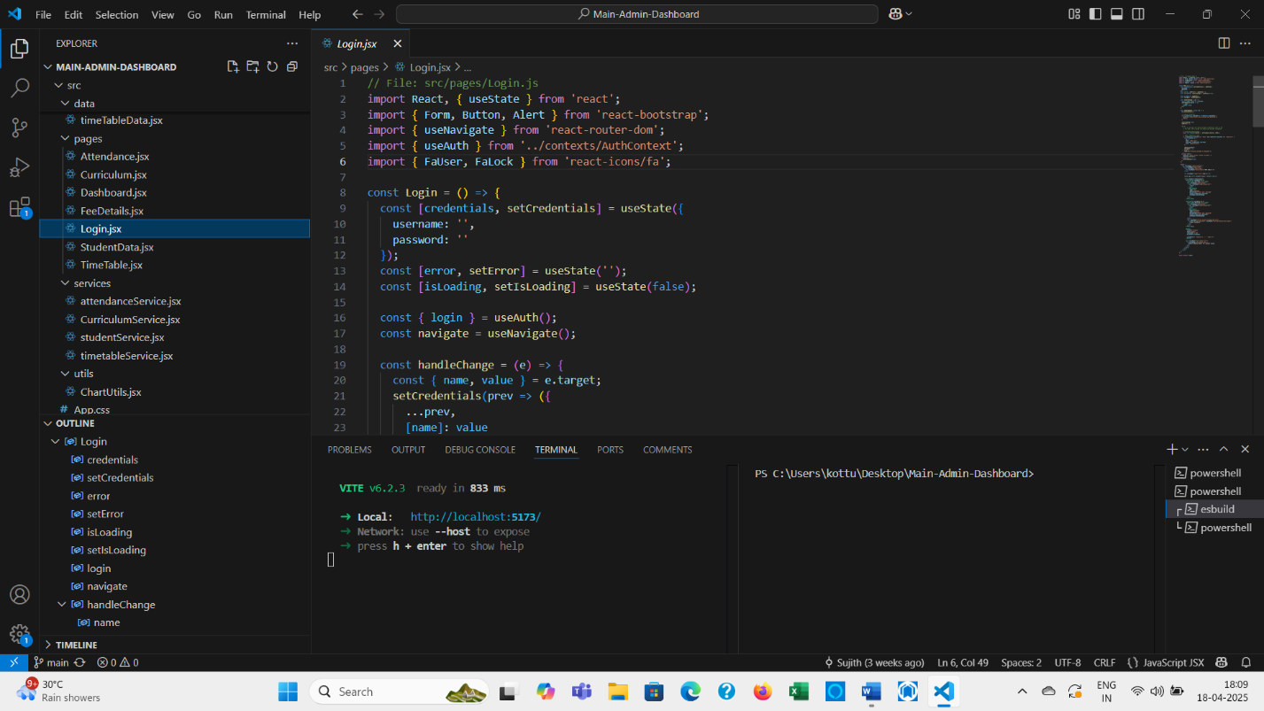

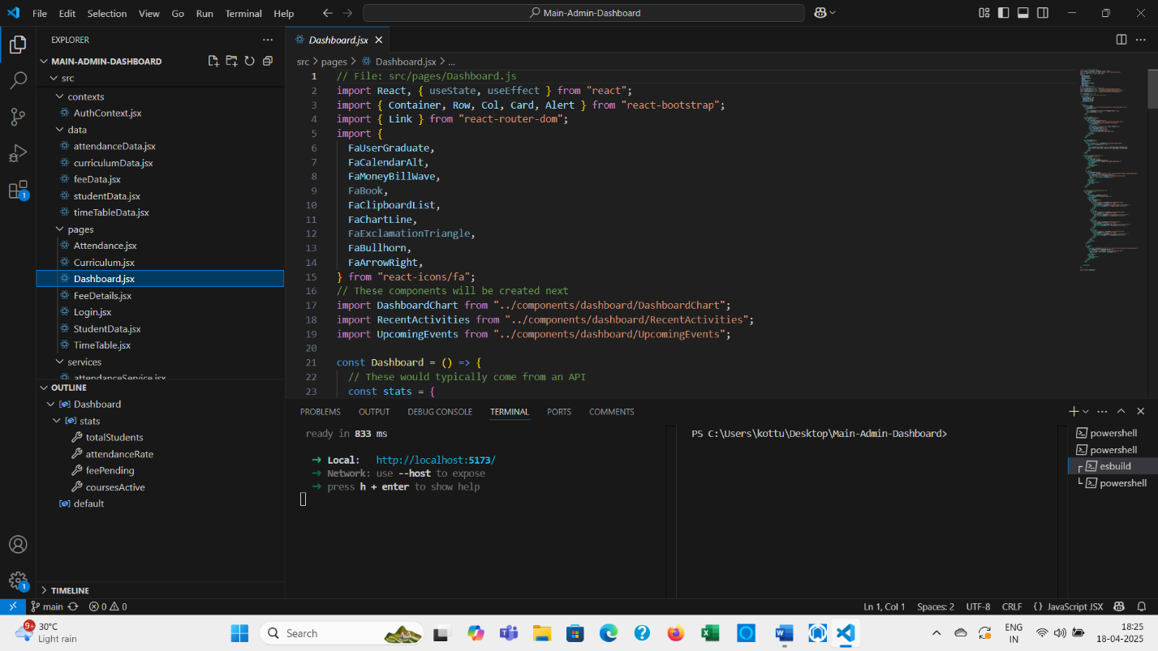

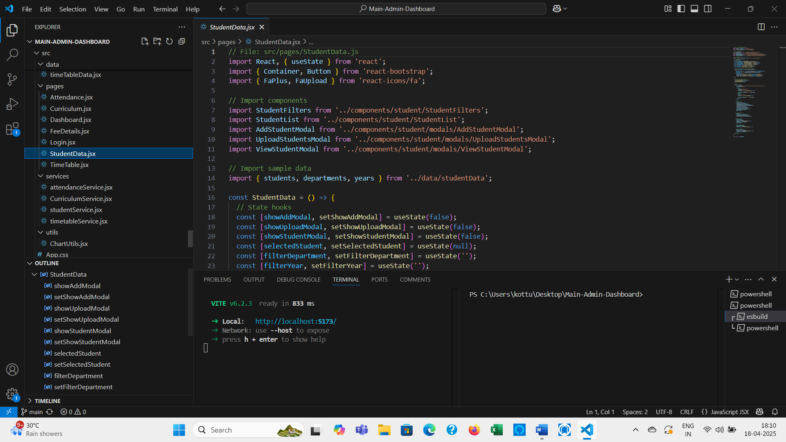

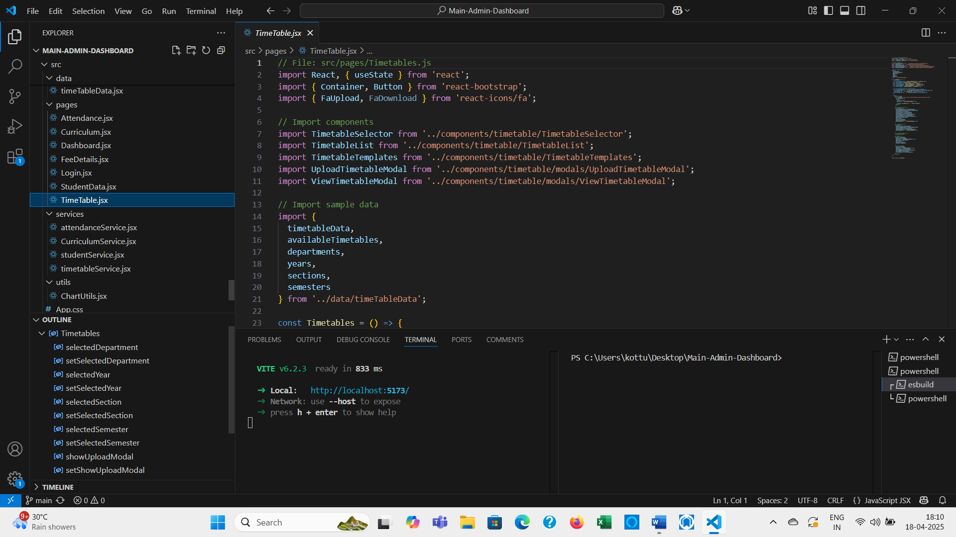

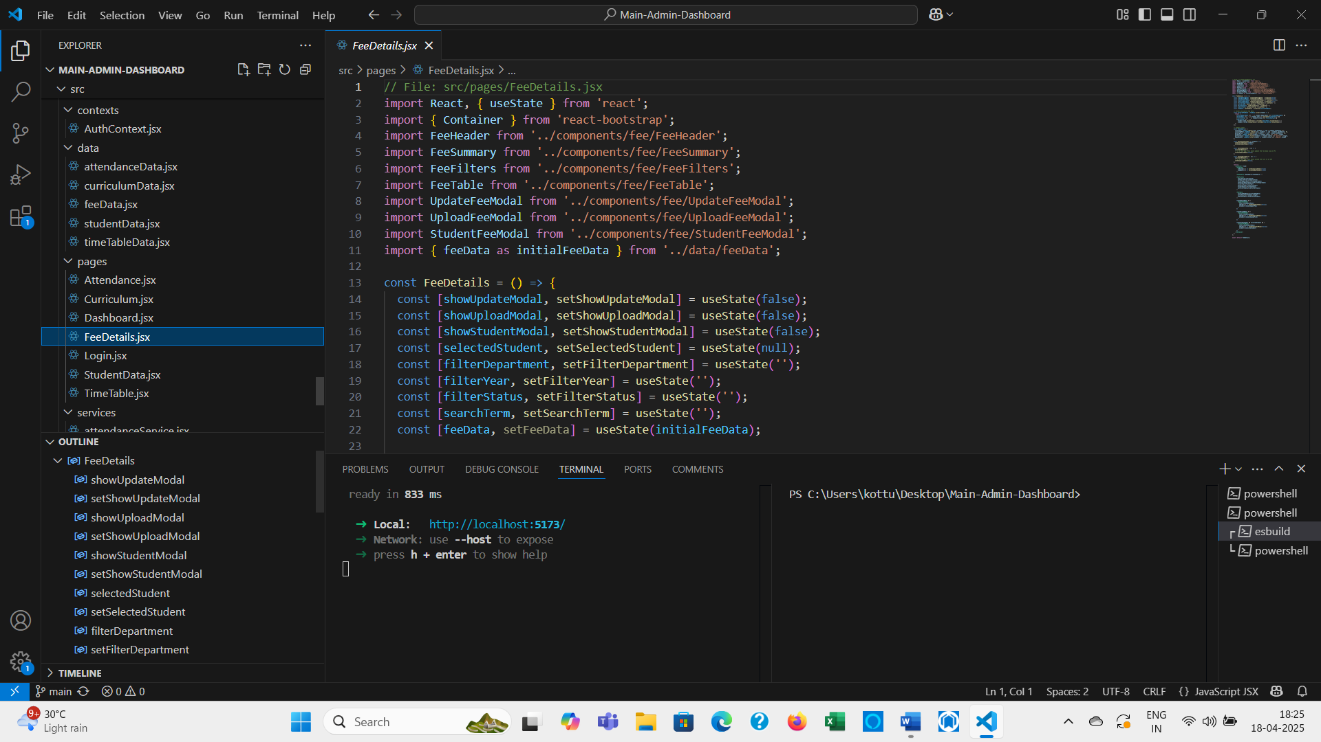

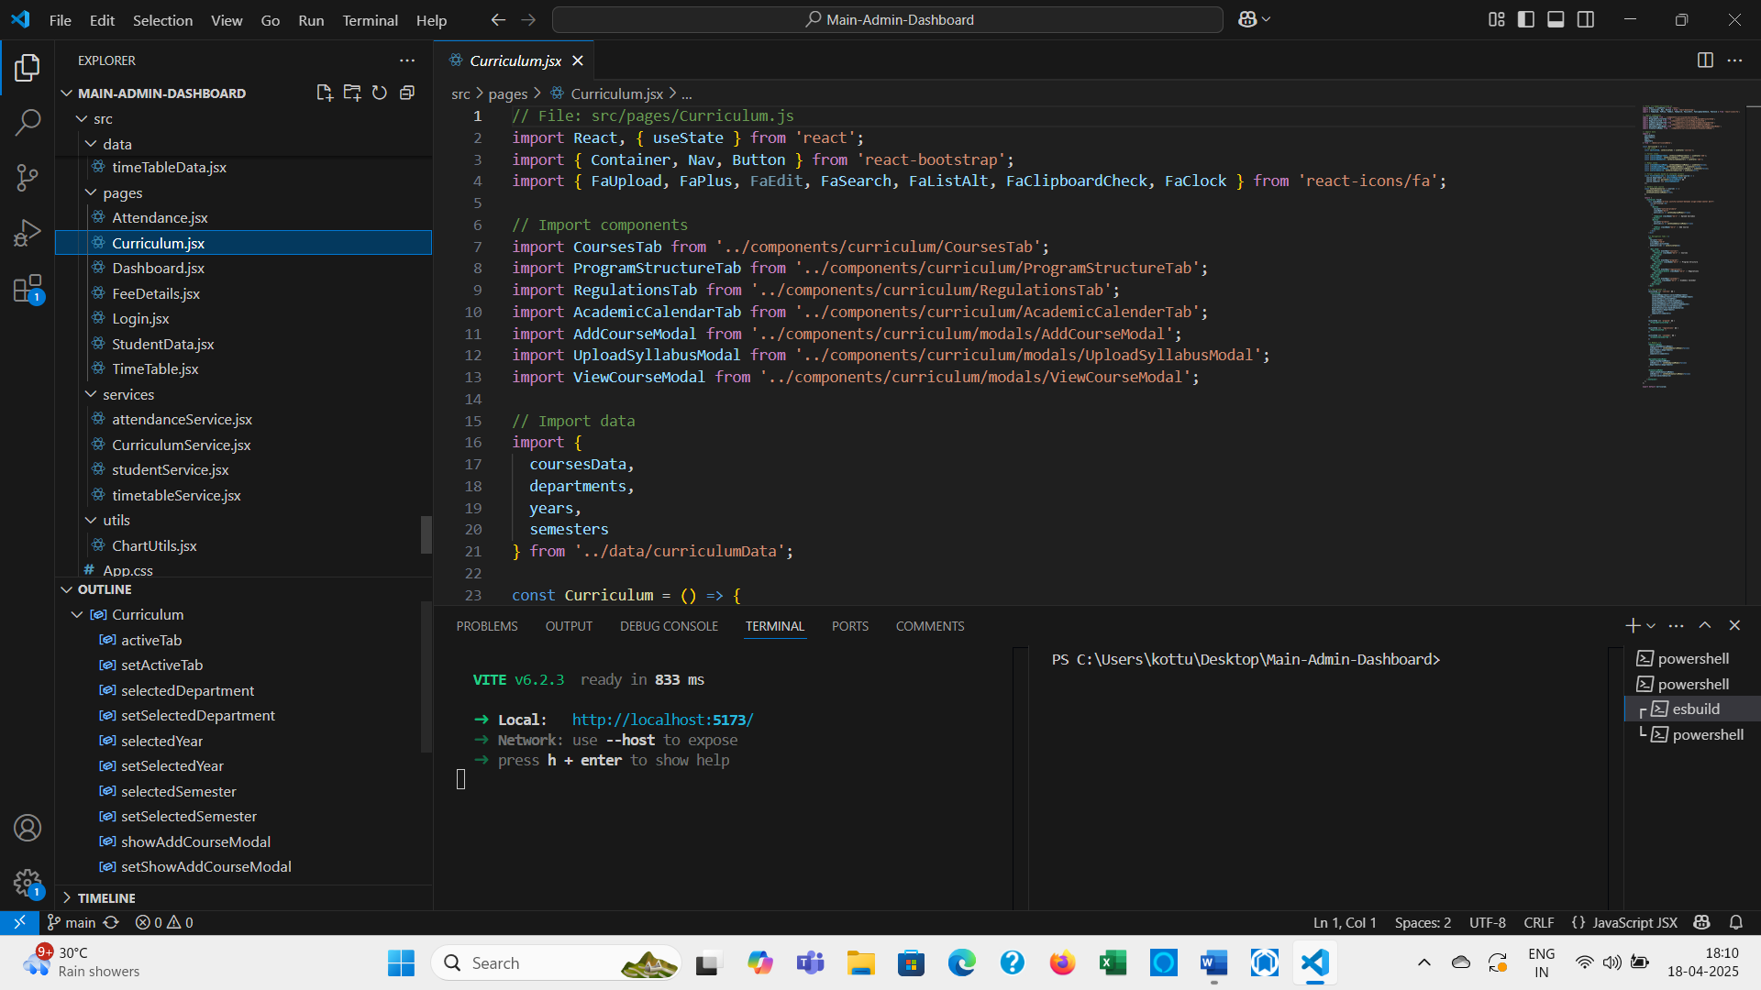

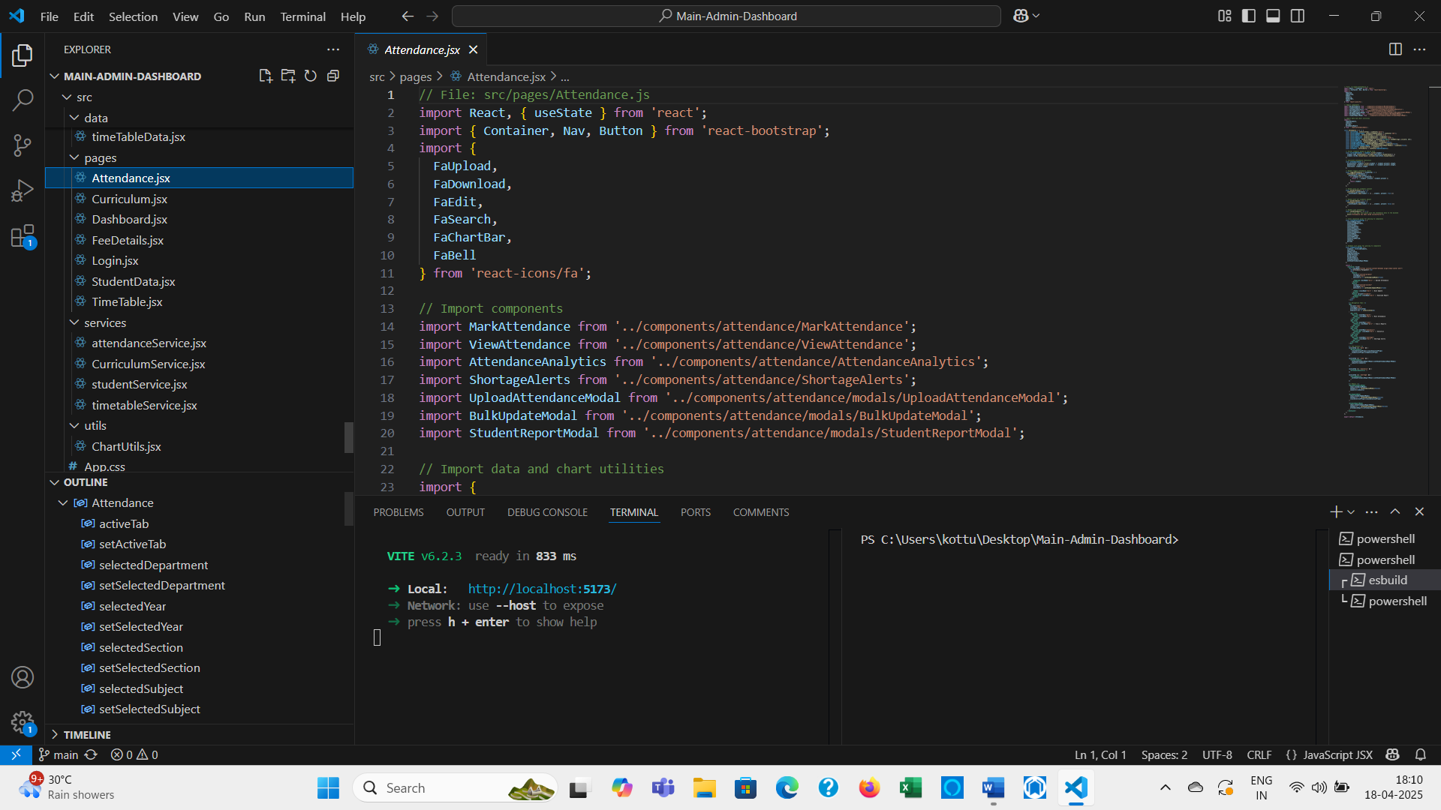

**LOGIN PAGE:**

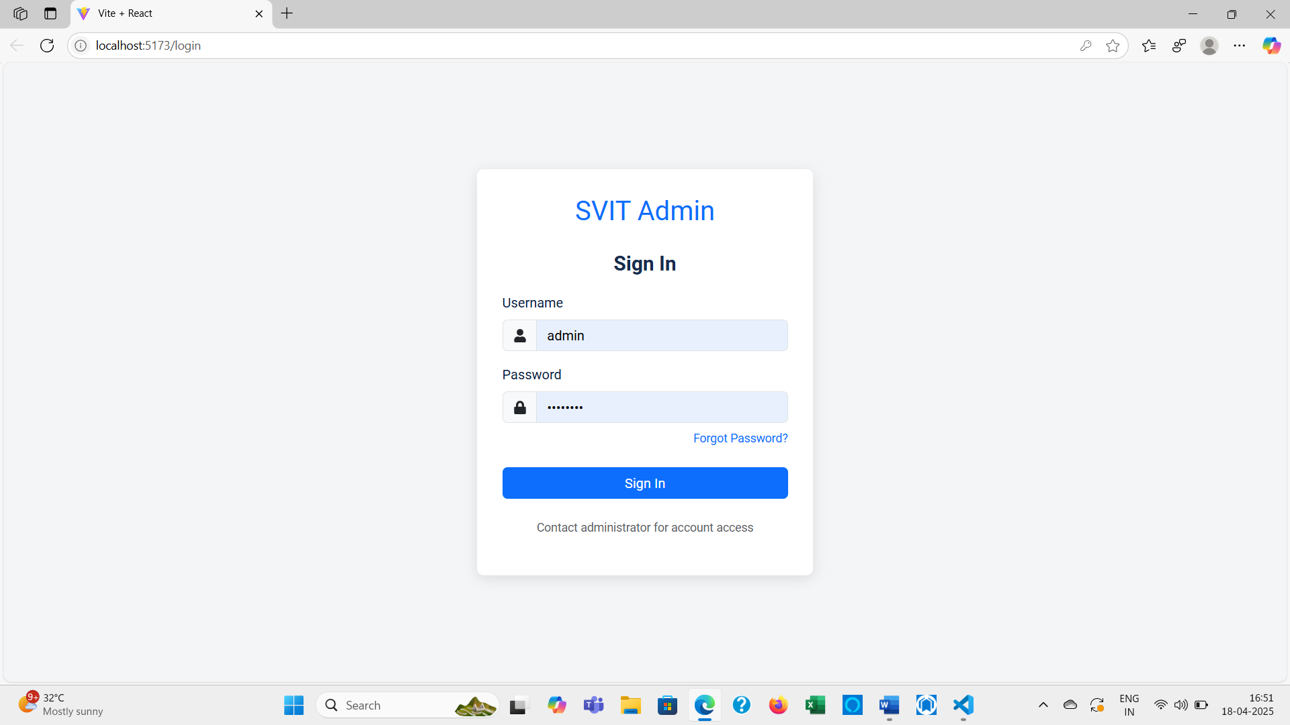

**DASHBOARD:**

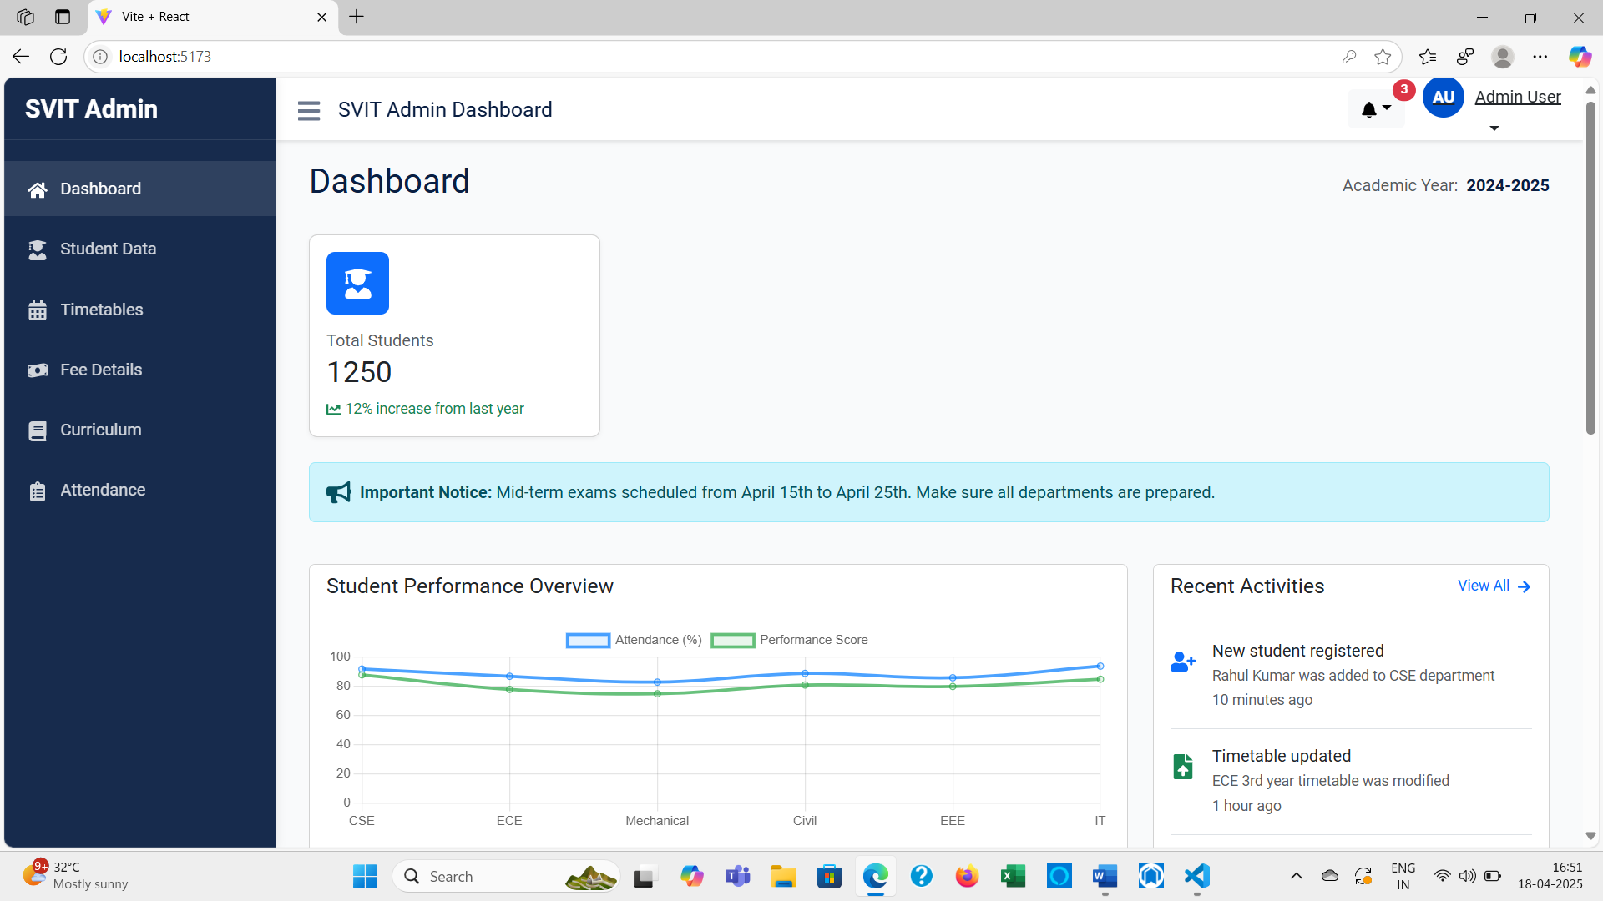

**STUDENT DATA:**

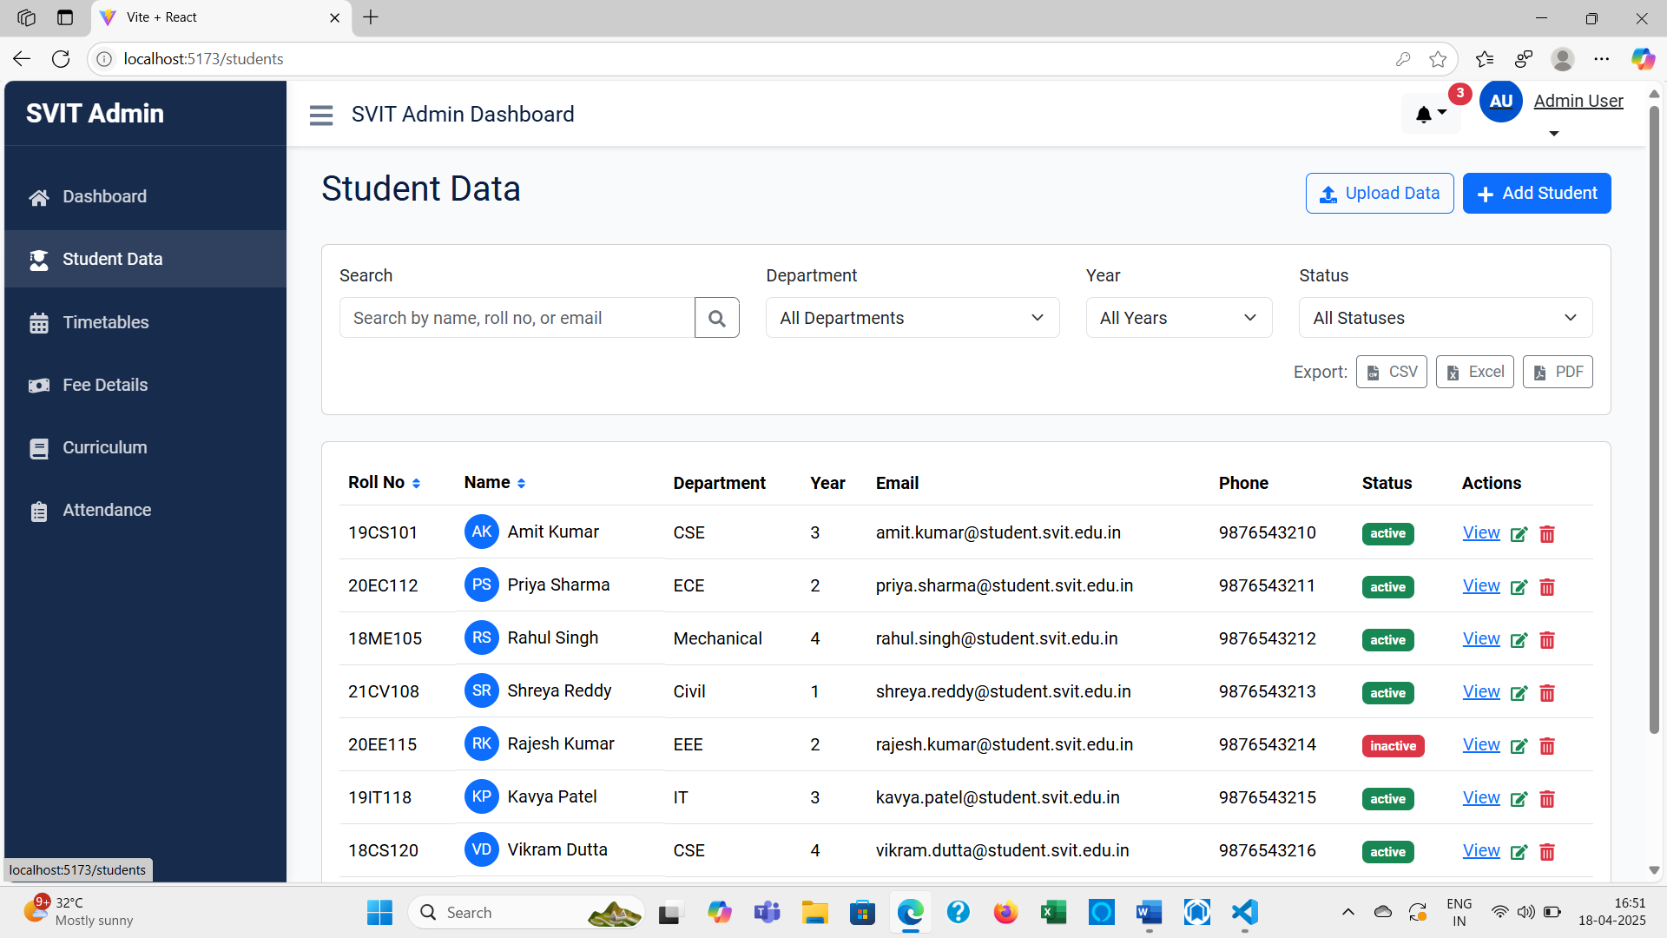

**TIMETABLE:**

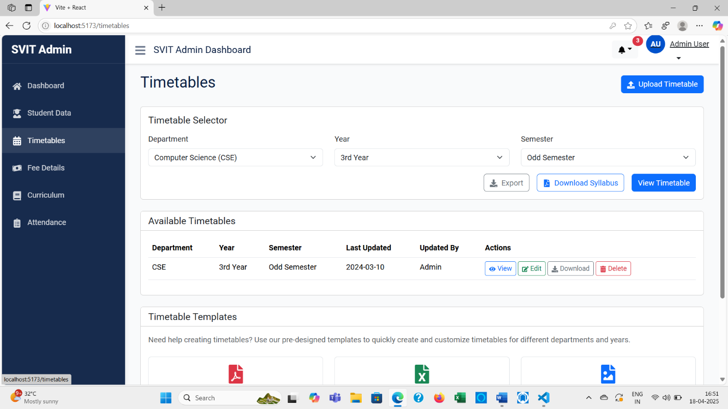

**FEE DETAILS:**

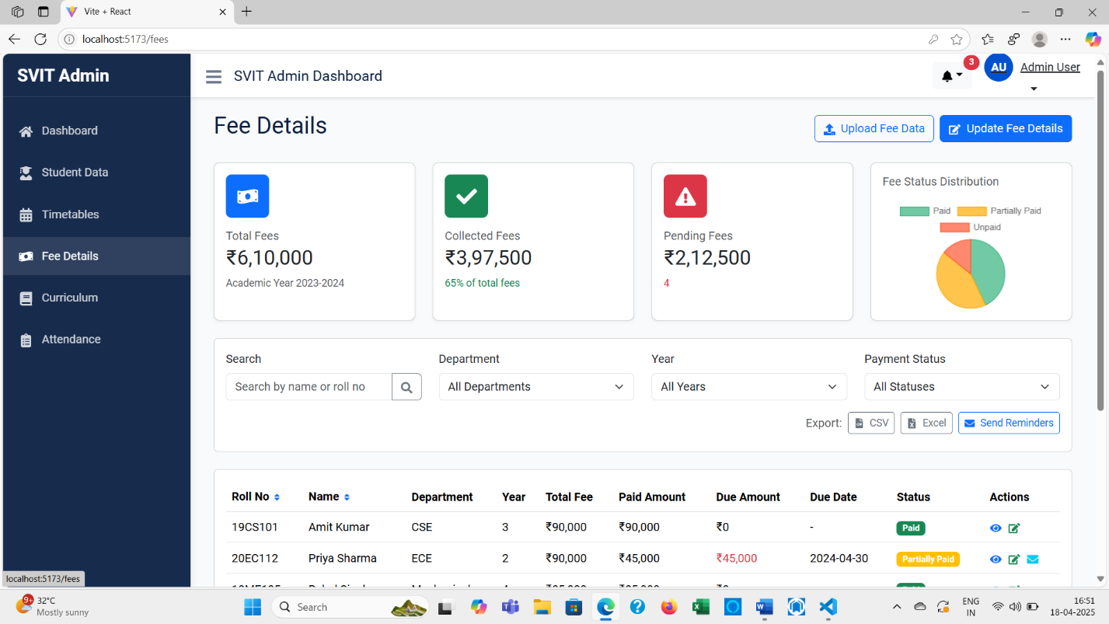

**CURRICULUM:**

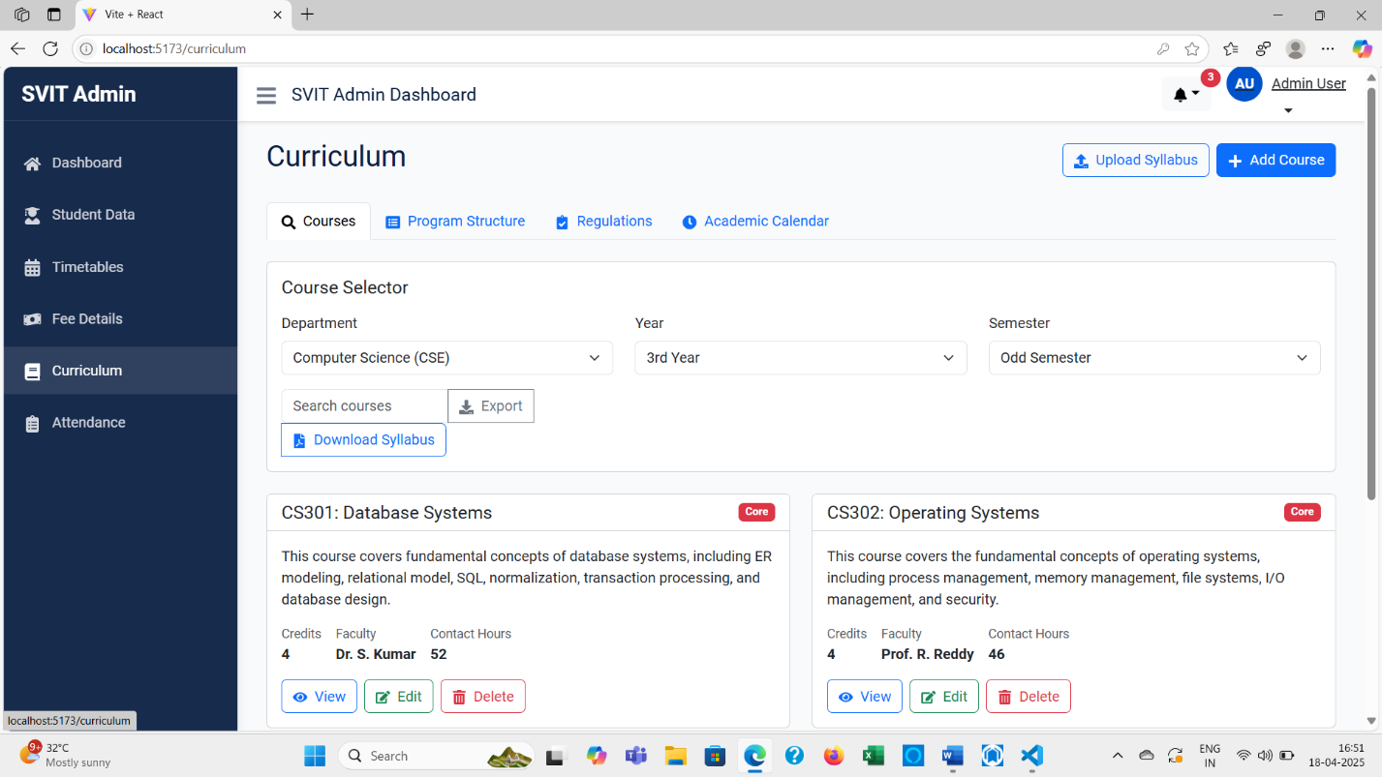

**ATTENDANCE:**

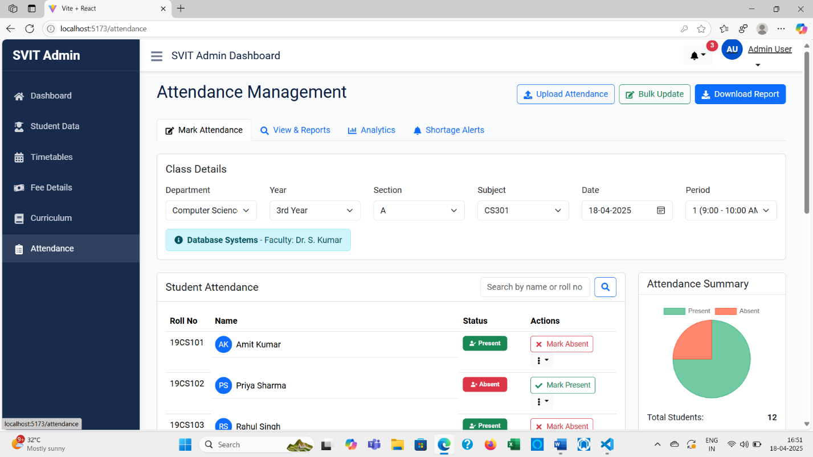

**6. SYSTEM TESTING**

System testing is a critical phase in the software development lifecycle. It involves evaluating the system to ensure it meets the specified requirements and user expectations. The purpose of testing is to identify errors, faults, or weaknesses in the software. It verifies the functionality of components and the overall system.

* **6.1 Feasibility Study**

A feasibility study is conducted to assess the viability of the project. It involves evaluating various factors to determine if the project is worth pursuing.

○ **6.1.1 Economic Feasibility**

This study examines the cost-effectiveness of the proposed system. It analyzes the financial resources required for development and implementation against the potential benefits. If the project is within the budget constraints and the benefits outweigh the costs, it is considered economically feasible.

○ **6.1.2 Technical Feasibility**

This study assesses the technical requirements and resources needed for the system. It evaluates the availability of hardware, software, and expertise to develop and implement the system. The system should not place excessive demands on available technical resources. If the necessary technology and skills are available, the project is technically feasible.

○ **6.1.3 Social Feasibility**

This study evaluates the acceptance of the system by its users. It considers the impact of the system on users and how they will adapt to it. User training and addressing concerns are crucial for social feasibility. If users are likely to accept and use the system effectively, it is considered socially feasible.

* **6.2 Types of Testing**

Different types of testing are employed to evaluate various aspects of the system. Each type of test serves a specific purpose in the testing process.

○ **6.2.1 Unit Testing**

Unit testing involves testing individual software units or components. It verifies that each unit functions correctly in isolation. This type of testing focuses on internal program logic and ensures that inputs produce valid outputs.

○ **6.2.2 Integration Testing**

Integration testing evaluates the interaction between integrated software components. It checks if the components function correctly as a combined system. This testing type aims to identify issues that arise from the integration of different components.

○ **6.2.3 Functional Testing**

Functional testing verifies that the system functions as specified by the requirements. It ensures that the system provides the features and functions that users expect. This testing type covers aspects such as valid input, invalid input, output, and system procedures.

○ **6.2.4 Usability Testing**

Usability testing assesses the user-friendliness and ease of use of the system. It evaluates how users interact with the system and identifies any usability issues. This type of testing focuses on factors such as ease of navigation, clarity of instructions, and overall user satisfaction.

○ **6.2.5 Performance Testing**

Performance testing evaluates the system's performance under various conditions. It assesses factors such as speed, responsiveness, stability, and scalability. This type of testing ensures that the system can handle expected workloads and perform efficiently.

○ **6.2.6 Security Testing**

Security testing assesses the system's security and vulnerability to threats. It evaluates the system's ability to protect data and prevent unauthorized access. This type of testing checks for potential security flaws and ensures that security measures are effective.

**6.3 Test Cases (for each module)**

Test cases are designed to verify that each module of the Admin Dashboard functions as intended. They cover various scenarios, including valid and invalid inputs, boundary conditions, and typical user interactions.

* 1. **Create Student - Valid Input:**

■ Input: Provide all required student details (name, ID, contact, program, etc.) in the correct format.

■ Expected Output: Student record created successfully.

* 1. **Create Student - Invalid Input:**

■ Input: Leave required fields blank or provide data in an incorrect format (e.g., non-numeric ID, invalid email).

■ Expected Output: Error message displayed, student record not created.

* 1. **Update Student Details:**

■ Input: Modify existing student information.

■ Expected Output: Student record updated successfully.

* 1. **Search Student - By ID:**

■ Input: Valid student ID.

■ Expected Output: Student record with the provided ID is displayed.

* 1. **Search Student - By Name:**

■ Input: Valid student name or partial name.

■ Expected Output: Student records matching the name are displayed.

* 1. **Delete Student:**

■ Input: Select a student record and initiate deletion.

■ Expected Output: Student record is removed from the system (with confirmation).

* **2. Timetable Scheduling Module** 
  + 1. **Create Timetable - Valid Input:**

■ Input: Provide all necessary timetable details (class, subject, teacher, time, etc.) without conflicts.

■ Expected Output: Timetable entry created successfully.

* + 1. **Create Timetable - Scheduling Conflict:**

■ Input: Attempt to schedule a class that overlaps with an existing class for the same teacher or classroom.

■ Expected Output: Error message indicating the conflict, timetable not created.

* + 1. **Update Timetable:**

■ Input: Modify an existing timetable entry.

■ Expected Output: Timetable entry updated successfully.

* + 1. **View Timetable - By Class:**

■ Input: Select a specific class.

■ Expected Output: Timetable for the selected class is displayed.

* + 1. **View Timetable - By Teacher:**

■ Input: Select a specific teacher.

■ Expected Output: Timetable for the selected teacher is displayed.

* **3. Fee Management Module** 
  + 1. **Record Fee Payment - Valid:**

■ Input: Enter valid fee payment details (student ID, amount, date).

■ Expected Output: Fee payment recorded successfully.

* + 1. **Record Fee Payment - Invalid Amount:**

■ Input: Enter a non-numeric or negative fee amount.

■ Expected Output: Error message displayed, payment not recorded.

* + 1. **Generate Fee Invoice:**

■ Input: Select a student and request a fee invoice.

■ Expected Output: Fee invoice generated with correct details.

* + 1. **View Fee Dues:**

■ Input: Select a class or a group of students.

■ Expected Output: List of students with outstanding fee dues is displayed.

* + 1. **Update Fee Status:**

■ Input: Modify the payment status of a fee record.

■ Expected Output: Fee status updated successfully.

**4. Curriculum Management Module**

* + 1. **Add Course - Valid Input:**

■ Input: Enter all required course details (course code, name, description, etc.).

■ Expected Output: Course added successfully to the curriculum.

* + 1. **Add Course - Duplicate Course Code:**

■ Input: Enter a course with a course code that already exists.

■ Expected Output: Error message, course not added.

* + 1. **Update Course Details:**

■ Input: Modify existing course information.

■ Expected Output: Course details updated successfully.

* + 1. **View Course Details:**

■ Input: Select a course.

■ Expected Output: Details of the selected course are displayed.

* + 1. **Delete Course:**

■ Input: Select a course and initiate deletion.

■ Expected Output: Course is removed from the curriculum (with confirmation).

**5. Attendance Management Module**

* + 1. **Record Attendance - Present:**

■ Input: Mark a student as "Present" for a specific class.

■ Expected Output: Attendance recorded as "Present" in the system.

* + 1. **Record Attendance - Absent:**

■ Input: Mark a student as "Absent" for a specific class.

■ Expected Output: Attendance recorded as "Absent" in the system.

* + 1. **Generate Attendance Report - By Date:**

■ Input: Select a specific date.

■ Expected Output: Attendance report for the selected date is generated.

* + 1. **Generate Attendance Report - By Student:**

■ Input: Select a specific student.

■ Expected Output: Attendance report for the selected student is generated.

* + 1. **Modify Attendance Record:**

■ Input: Change an existing attendance record.

■ Expected Output: Attendance record is modified successfully.

**7.Conclusion**

The development of this Admin Dashboard addresses the critical need for a centralized and efficient system to manage academic and administrative tasks within educational institutions. By providing modules for student management, timetable scheduling, fee management, curriculum management, and attendance management, the dashboard streamlines workflows, reduces manual effort, and enhances data accuracy.

The implementation of this system offers significant advantages, including improved efficiency, enhanced data accuracy, and centralized communication. The user-friendly interface and robust functionalities empower administrators to effectively manage institutional operations, leading to better decision-making and improved overall productivity.

In conclusion, this Admin Dashboard provides a valuable tool for modernizing educational administration, fostering a more organized, efficient, and data-driven environment for educators, students, and parents.

* 1. **Future Enhancements**

While the current Admin Dashboard provides a strong foundation for managing academic and administrative tasks, there are several avenues for future enhancements that could further extend its functionality and value. These enhancements aim to address evolving needs, incorporate new technologies, and provide a more comprehensive and integrated solution for educational institutions.

* **Mobile Accessibility and Responsive Design:**

Developing a mobile application or ensuring full responsiveness of the dashboard on various mobile devices would provide administrators with greater flexibility and accessibility. This would enable them to manage tasks, access information, and receive notifications on the go, improving efficiency and responsiveness. Features could be optimized for mobile use, such as push notifications, simplified interfaces, and offline access to certain data.

* **Advanced Analytics and Reporting:**

Implementing more advanced analytics and reporting features would provide administrators with deeper insights into institutional data and support data-driven decision-making.

○ This could include features such as:

Predictive analytics to forecast student enrollment trends or identify students at risk of academic failure. Customizable dashboards to display key performance indicators (KPIs) relevant to specific roles or departments. Automated report generation and distribution.

Data visualization tools to present complex data in a clear and understandable format.

* **Enhanced Communication and Collaboration Tools:**

Expanding the communication and collaboration features within the dashboard would further improve communication and engagement among stakeholders.

○ This could include features such as:

Integrated messaging or chat functionality for real-time communication. Discussion forums or collaboration spaces for students and faculty. Automated notifications and alerts for important events or deadlines. Integration with external communication platforms (e.g., email, SMS).

* **Automation of Administrative Tasks:**

Further automating routine administrative tasks would free up staff time and reduce the potential for errors.

○ This could include features such as:

Automated student enrollment and registration processes.Automated generation of certificates and transcripts. Automated scheduling of events and meetings. Automated processing of applications and forms.

* **Integration with Payment Gateways:**

Direct integration with online payment gateways would streamline the fee payment process for students and reduce manual processing for administrators.

This would enable students to pay fees online conveniently and securely, while also automating the recording and tracking of payments.

* **Support for Multiple Campuses or Institutions:**

Extending the system to support multiple campuses or institutions would make it a more scalable and versatile solution.

This would require features such as:

Hierarchical user management and access control. Centralized data management with the ability to segment data by campus or institution.Customizable settings and configurations for different campuses or institutions.

### 9.Reference

1. CSS detailed notes available at

<https://books.goalkicker.com/CSSBook/#google_vignette>

1. HTML detailed notes available at<https://codersguild.net/books/html-css/html-css-crash-course>
2. Bootstrap detailed notes available at

<https://pepa.holla.cz/wp-content/uploads/2015/10/Bootstrap.pdf>

**d.**Java Script detailed notes available at <https://basponccollege.org/LMS/EMaterial/Science/Comp/HVP/JS%20Notes.pdf>

e.Express+Node JS detailed notes available at

<https://www.freecodecamp.org/news/the-express-handbook/>